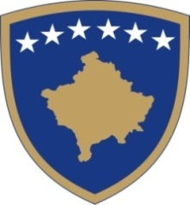
Republika e Kosovës
Republika Kosovo - Republic of Kosovo
Qeveria - Vlada – Government

Ministria e Kulturës, Rinisë dhe Sportit – Ministarstvo Kulturu, Omladine i Sporta - Ministry of Cultur, Youth and Sports

Respondents | Ministry | Reasoning of  proposing  body  for  inclusion  or  non-inclusion  of  comment  given | NGO | Reasoning of  proposing  body  for inclusion  or  non-inclusion  of comment  given | Ministry | Reasoning of  proposing  body for  inclusion or  non-inclusion of  comment  given
Key
Issues 1
Key
Issues 2
Key
Issues 3
Key
Issues 4
Key
Issues 5

