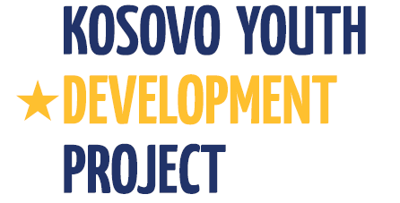
Kosovo Youth Development Project
Project Implementation Unit – PIU
Ministry of Culture, Youth and Sports / Department of Youth
Government of Kosovo

REQUEST FOR EXPRESSIONS OF INTEREST
Kosovo
Kosovo Youth Development Project 2
Grant No.:TF098547

Assignment Title: Kosovo Youth Development Project (KYDP) will contract a firm to conduct English Language Courses for 14 officials of the Department of Youth

Reference No (as per Procurement Plan): 17.2

The Ministry of Culture, Youth and Sports/Department of Youth has received financing from the World Bank toward the cost of the Second Kosovo Youth Development Project, being implemented by the Project Implementation Unit, and intends to apply part of the proceeds for consulting services.

The objective of the assignment is to provide training to Enhance English Language skills for the DoY officials by providing English Language training that will meet the requirement of engagements in their day-to-day job activities and liaison with different international stakeholders. The program should be designed as non-formal education programs, tailored to the needs of the DoY officials.

Specific tasks for the company will include:

- Consult with the Project Team for a general orientation of the course;
- Conduct testing of knowledge on English Language for DoY officials to estimate their level of English and allocate them at respective course level. It is expected that each DoY participant will attend not less than 2 English modules
- Deliver maximum two modules of English language to trainees, followed with certificate of attendance, indicating the trainee level of knowledge achieved
- Report to PIU on trainees advancement on monthly basis.

The approximate duration of assignment will be around 10 months, including tests. The schedule and plan of assignment will be developed in close consultation and coordination with PIU.

Minimum qualification criteria:
- Be legally registered
- A minimum of five years of work experience in delivering of English Language courses;
- Qualified teachers that have formal teaching skills and practical hands-on ability to communicate relevant concepts, tools and techniques, for development of training courses;
- An institution that uses the most up-to-date English language materials published
- Well-equipped classrooms with modern teaching aids – audio and video playback and access to online and disk based resources

Interested Consultants should provide information demonstrating that they have the required qualifications and relevant experience to perform the Services. The shortlisting criteria are:

Firm's experience in developing, organizing and implementing similar assignments (English courses) | 50 points
Availability of qualified key staff within the firm | 20 points
Organization of firm and staffing (including number of years in business; number of permanent staff within the firm) | 30 points

"A consulting firm will be selected using the selection based on Consultants Qualification (CQ) in accordance with the procedures set forth in the World Bank’s Guidelines: Selection and Employment of Consultants under IBRD Loans and IDA Credits & Grants by World Bank Borrowers (“Consultant Guidelines”), edition of May 2004, revised October 2006 and May 2010, para 3.7".
Further information can be obtained at the address below during office hours: 09: 00 to 16:00.

Expressions of interest must be delivered in a written form to the address below (in person, or by mail, or by fax, or by e-mail) by 21.05.2012

The Ministry of Culture, Youth and Sports/Department of Youth
Project Implementation Unit – PIU
Mother Theresa Square #35; Office #25;
10000, Prishtina, Republic of Kosova
Attn: Arton Çitaku – Procurement and Administration Specialist
Tel: +381 (0)38 200 22 081;
E-mail: arton.citaku@rks-gov.net

